Name

Mathematics Advanced Year 11
Trigonometric Identities and Equations

Book 1 |  | Version: 261007  Feedback:  https://MrDingMaths.com
Contents
Syllabus Content 2
Learning Intention 3

Syllabus Content
MAV-11-05 uses periodic functions to solve trigonometric equations and prove trigonometric identities
- Define the trigonometric functions $\sec{θ}$, $cosecθ$ and $\cot{θ}$ for acute angles $θ$ using ratios of sides in a right-angled triangle
- Find the exact secant, cosecant and cotangent ratios for angles of $30°$, $45°$ and $60°$
- Justify the values of $\sec{θ}$, $cosecθ$ and $\cot{θ}$ at $0°$ and $90°$ by examining the ratios of sides in a right-angled triangle as $θ$ tends to $0°$ and $90°$
- Develop the definitions $\sec{θ=\frac{r}{x}}$, $cosecθ=\frac{r}{y}$ and $\cot{θ}=\frac{x}{y}$ using a circle of radius $r$ centred at the origin
- Establish the reciprocal ratios $\sec{A}= \frac{1}{cos A}$, $cosec A = \frac{1}{sin A}$, and $\cot{A}= \frac{1}{tan A}$, identifying the angles to be excluded in each identity
- Determine the exact value of the secant, cosecant and cotangent ratios for angles that are integer multiples of $\frac{π}{6}$ and $\frac{π}{4}$, if they exist
- Establish the identities $\tan{θ}=\frac{\sin{θ}}{\cos{θ}}$ and $\cot{θ}=\frac{\cos{θ}}{\sin{θ}}$, identifying the angles to be excluded in each identity
- Prove the complementary angle identities $\sin{(90°-}θ)=\cos{θ}$, $\cos{(90°-θ)=sin}{θ}$, $\tan{(90°-θ)=cot}{θ}$, $\cot{(90°-θ)=tan}{θ}$, $\sec{(90°-θ)=cosec}{θ}$ and $\operatorname{cosec}{(90°-θ)=sec}{θ}$ identifying the angles to be excluded in each identity
- Evaluate trigonometric expressions using angles of any magnitude and complementary angle identities
- Solve equations involving trigonometric ratios of angles, specified in degrees or radians, on a restricted domain
- Prove the Pythagorean identity $\cos^{2}x+\sin^{2}x=1$, and the identities ${1+tan}^{2}x=\sec^{2}x$ and $1+\cot^{2}x={cosec}^{2}x$
- Apply trigonometric identities to solve problems, simplify expressions and prove further trigonometric identities using substitution and/or reduction to $\sin{x}$ and $\cos{x}$
- Solve problems involving trigonometric equations, including those that reduce to quadratic equations, on a restricted domain

Reciprocal Trigonometric Functions

- Reciprocal Trig Functions
$$\operatorname{cosec}{θ}=\frac{1 }{sin θ}=\frac{Hyp}{Opp} \\ \sec{θ}=\frac{1}{cos θ}=\frac{Hyp}{Adj} \\ \cot{θ}=\frac{1}{tan θ}=\frac{Adj}{Opp}=\frac{\cos{θ}}{\sin{θ}}$$

- Example Identify cosec, sec, and cot
For the triangle, determine:
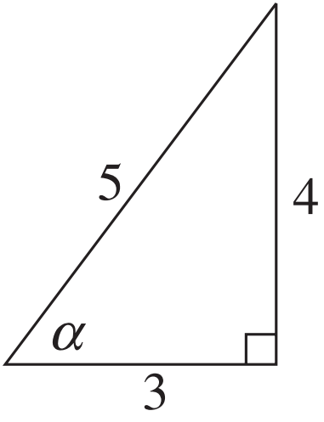
$$\operatorname{cosec}{α}=\frac{Hyp}{Opp}=\frac{5}{4}$$
$$\sec{α}=\frac{Hyp}{Adj}=\frac{5}{3}$$
$$\cot{α}=\frac{Adj}{Opp}=\frac{3}{4}$$

- Guided Practice
Identify the cosecant, secant, and cotangent ratios of this triangle
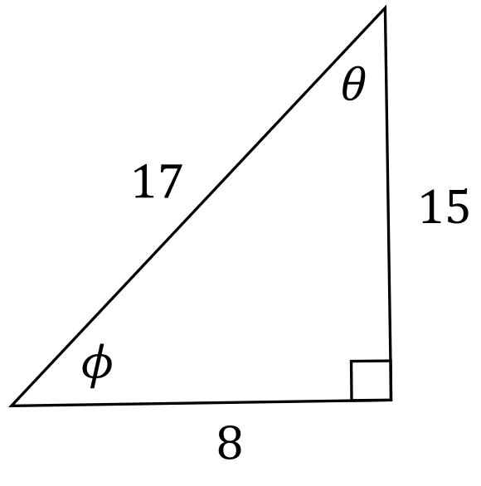
$$\operatorname{cosec}{θ}=$$  $$\frac{17}{8}$$  $$\sec{θ}=$$  $$\frac{17}{15}$$  $$\cot{θ}=$$  $$\frac{15}{8}$$ | $$\operatorname{cosec}{ϕ}=$$  $$\frac{17}{15}$$  $$\sec{ϕ}=$$  $$\frac{17}{8}$$  $$\cot{ϕ}=$$  $$\frac{8}{15}$$

Foundation
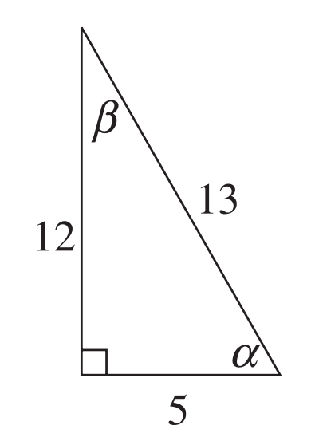
- Using the diagram, write down the values of:
- $\sin{α}$  $$\frac{12}{13}$$ | - $\tan{β}$  $$\frac{5}{12}$$
- $\sec{β}$  $$\frac{13}{12}$$ | - $\cot{α}$  $$\frac{5}{12}$$
- $cosec α$  $$\frac{13}{12}$$ | - $\sec{α}$  $$\frac{13}{5}$$

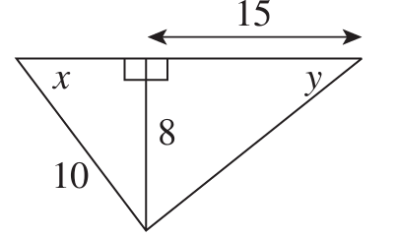
- Use Pythagoras’ theorem to find the unknown side in each of the two right-angled triangles, then find the values of the following trigonometric ratios.
- $\cot{x}$  $$\frac{3}{4}$$ | - $\operatorname{cosec}{y}$  $$\frac{17}{8}$$
- $\sec{x}$  $$\frac{5}{3}$$ | - $\cot{y}$  $$\frac{15}{8}$$

- Use your calculator to evaluate, to 2 decimal places:
- $\sec{50°23'}$  1.57 | - $cosec 37°52'$  1.63 | - $\cot{17°47'}$  3.12

- Use your calculator find the acute angle $θ$ to the nearest minute.
- $\sec{θ}=4$  $$75°31'$$ | - $cosec θ=$ $\frac{7}{5}$  $$45°35'$$ | - $\cot{θ}=0.27$  $$74°53'$$

- Without using a calculator, find the exact value of $cosec^{2}30°-\cot^{2}{30°}$
$${\left(\frac{1}{\sin{30°}}\right)}^{2}-{\left(\frac{1}{\tan{30°}}\right)}^{2}$$
$$={\left(\frac{1}{\left(\frac{1}{2}\right)}\right)}^{2}-{\left(\frac{1}{\frac{1}{\sqrt{3}}}\right)}^{2}$$
$$={\left(2\right)}^{2}-{\left(\sqrt{3}\right)}^{2}$$
$$=1$$
- Without using a calculator, prove that $\frac{1}{\sec{30°}-\tan{30°}}$ $=\sqrt{3}$
$$\frac{1}{\left(\frac{1}{\cos{30°}}\right)-\tan{30°}}$$
$$=\frac{1}{\frac{2}{\sqrt{3}}-\frac{1}{\sqrt{3}}}$$
$$=\frac{1}{\left(\frac{1}{\sqrt{3}}\right)}=\sqrt{3}$$

Development
- Find the exact value of:
- $cosec 150°$  2 | - $\sec{225°}$  $$-\sqrt{2}$$ | - $\cot{120°}$  $$-\frac{1}{\sqrt{3}}$$
- $cot 210°$  $$\sqrt{3}$$ | - $\sec{330°}$  $$\frac{2}{\sqrt{3}}$$ | - $\operatorname{cosec}{300°}$  $$-\frac{2}{\sqrt{3}}$$
- $sec\frac{π}{4}$  $$\sqrt{2}$$ | - $\cot{\frac{π}{3}}$  $$\frac{1}{\sqrt{3}}$$ | - $\operatorname{cosec}{\frac{π}{6}}$  $$2$$
- $cosec\frac{π}{4}$  $$\sqrt{2}$$ | - $\sec{\frac{π}{6}}$  $$\frac{2}{\sqrt{3}}$$ | - $\cot{\frac{π}{6}}$  $$\sqrt{3}$$

- Find the exact value of:
- $sec 0°$  1 | - $\operatorname{cosec}{270°}$  $$-1$$ | - $\sec{90°}$  undefined
- $cosec 180°$  undefined | - $\cot{270°}$  $$\frac{\cos{270°}}{\sin{270°}}=0$$ | - $\sec{90°}$  undefined

- Given that tan 35° ≑ 0.70 and sec 35° ≑ 1.22, write down approximate values, without using a calculator, for:
- $\tan{145°}$  $$-0.70$$ | - $\sec{215°}$  $$-1.22$$ | - $\tan{325°}$  $$-0.70$$
- $tan 215°+\sec{145°}$  $$-0.52$$ | - $\sec{325°}+\tan{395°}$  $$1.92$$ | - $\sec\left(-145°\right)-\tan{(-215°})$  $$-0.52$$

- HSC Advanced Sample Question Band 3
Find the exact value of $\cot\left(-\frac{5π}{6}\right)$

$$\cot\left(-\frac{5π}{6}\right)=\cot\left(\frac{π}{6}\right)$$
$$=\sqrt{3}$$

- Prove that
$$\frac{\sin{120°}}{\tan{300°}}-\frac{\cos{240°}}{\cot{315°}}=\tan^{2}{240°}-{cosec}^{2}{330°}$$
$$LHS=\frac{\sin{60°}}{-\tan{60°}}-\frac{-\cos{60°}}{\left(\frac{1}{-tan{45°}}\right)}$$
$$=\frac{\left(\frac{\sqrt{3}}{2}\right)}{-\sqrt{3}}-\frac{-\frac{1}{2}}{\left(\frac{1}{-1}\right)}$$
$$=-\frac{1}{2}-\frac{1}{2}$$
$$=-1$$
$$RHS=\tan^{2}{60°}-\frac{1}{{-sin}^{2}{30°}}$$
$$=3-\frac{1}{\left(\frac{1}{4}\right)}$$
$$=-1$$

$$LHS=RHS$$
- Complete the table with exact values.
$θ$ | 0 | $$\frac{π}{2}$$ | $$π$$ | $$\frac{3π}{2}$$ | $$2π$$
$$\operatorname{cosec}{θ}$$ | undefined | 1 | undefined | $$-1$$ | undefined
$$\sec{θ}$$ | 1 | undefined | $$-1$$ | undefined | 1
$$\cot{θ}$$ | undefined | 0 | undefined | 0 | undefined

The 3 graphs below show the sketches of $y=\operatorname{cosec}{x}$, $y=\sec{x}$, $y=\cot{x}$ in domain $x∈\left[0,2π\right]$.
Label all key relevant points using your tables .

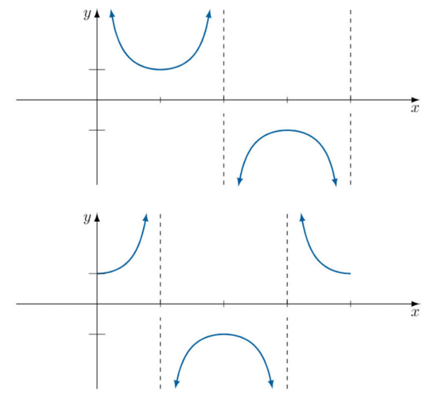
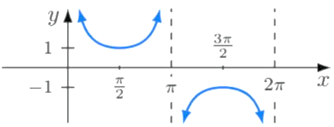

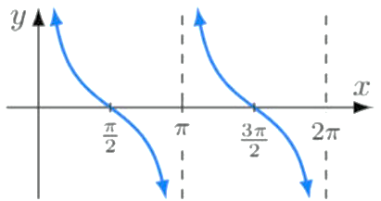
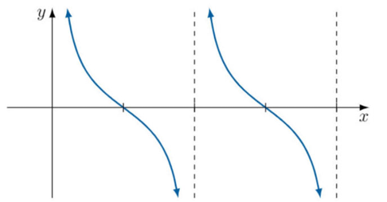

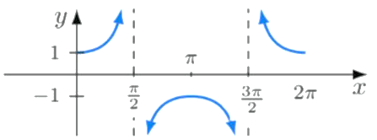

Cofunction Identities

- Cofunction Identities
For any angle $θ:$
$$\sin{θ}=\cos{(90°-θ)} \\ \cos{θ}=\sin{(90°-θ)}$$ | $$\sec{θ}=cosec \left(90°-θ\right) \\ cosec θ=\sec\left(90°-θ\right)$$ | $$\tan{θ}=\cot{(90°-θ}) \\ \cot{θ}=\tan{(90°-θ})$$

Foundation
- Simplify:
- $\sin\left(90°-θ\right)$  $$\cos{θ}$$ | - $\sec\left(90°-α\right)$  $$cosec α$$
- $\frac{1}{\cot\left(90°-β\right)}$  $$\cot{β}$$ | - $\frac{\cos\left(90°-ϕ\right)}{\sin\left(90°-ϕ\right)}$  $$\tan{ϕ}$$
- $\sec{θ}-cosec\left(90°-θ\right)$  0 | - $\tan{70°}+\cot{20°}-2\tan{70°}$  0
- $\frac{\sin{55°}}{\cos{35°}}$  1 | - $\frac{\cot{25°+\tan{65°}}}{\cot{25°}}$  2

- Find the value of $y$ if $\tan{22°}=\cot{(90°-y)}$

$$y = 22$$
- Find the value of $t$ if $\cot{(2t+5)°}=\tan{(3t-15)°}$

$$t = 20$$
- Find the value of $k$ if $\sec{(15 - k)°}$ $=\operatorname{cosec}{(2k+60)°}$

$$k = 15$$

Deriving a Trigonometric Ratio

- Deriving a Trigonometric Ratio, given another (Acute Angles)
When you are given a trigonometric ratio, you can find another without finding the angle.
- Draw a right-angled triangle, label it using the given ratio.
- Find the missing side.
- Use the triangle to find other trigonometric ratios.

- Example Derive a trigonometric ratio from another (acute angle).
If $\sin{θ}=\frac{5}{14}$ and $θ$ is acute, find $\cos{θ},\sec{θ}$ and $\cot{θ}.$
1. Draw triangle  $$\sin{θ}=\frac{5}{14}=\frac{Opp}{Hyp}$$  $$5$$  $$θ$$  $$14$$  $$\sqrt{171}$$ | 2. Find missing side  $$Adj=\sqrt{{14}^{2}-5^{2}}$$  $$=\sqrt{171}$$ | 3. Find other ratios  $$\cos{θ}$$  $$=\frac{Adj}{Hyp}=\frac{14}{5}$$  $\sec{θ}$  $$=\frac{1}{\cos{θ}}=\frac{Hyp}{Adj}=\frac{14}{\sqrt{171}}$$  $\cot{θ}$  $$=\frac{1}{\tan{θ}}=\frac{Adj}{Opp}=\frac{\sqrt{171}}{5}$$

- Guided Practice
If $\cos{θ}=\frac{4}{7}$ and $θ$ is acute, find $\sin{θ},\tan{θ},\cot{θ}$
1. Draw triangle | 2. Find missing side | 3. Find other ratios  $$\sin{θ}$$  $$\frac{\sqrt{33}}{7}$$  $\sec{θ}$  $$\frac{7}{4}$$  $\cot{θ}$  $$\frac{4}{\sqrt{33}}$$

- Deriving a Trigonometric Ratio, given another (Any Angle)
When the angle is not acute, determine the quadrant the triangle exists in, then use this information to ensure your answer has the correct sign.
- Draw a right-angled triangle, label it using the given ratio.
- Find the missing side.
- Identify the quadrant(s) using the sign of the given ratio.
- Find the new ratio with the correct sign.

- Example Derive a trigonometric ratio from another (acute angle).
If $\sin{θ}=\frac{1}{5}$, find the possible values of $\cos{θ}$ in exact form.
1. Draw triangle  2. Find missing side  $$\sin{θ}=\frac{1}{5}=\frac{Opp}{Hyp}$$  $$1$$  $$θ$$  $$5$$  $$2\sqrt{6}$$  $$Adj=\sqrt{5^{2}-1^{2}}$$  $=\sqrt{24}$  $=2\sqrt{6}$ | 3. Identify quadrant and sign  sin is positive, so Q1 and Q2  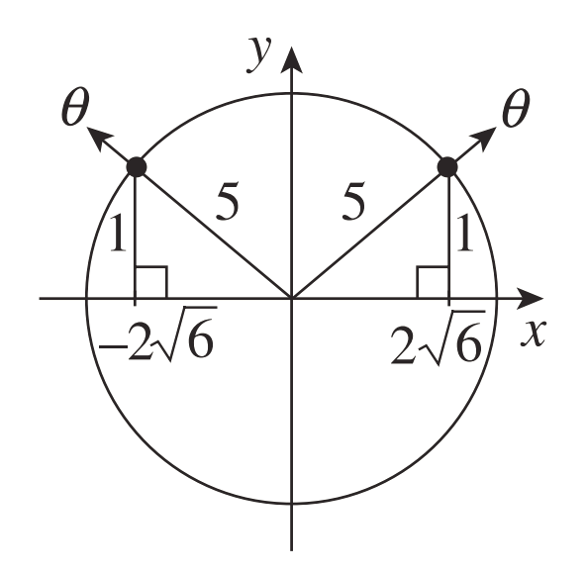 | 4. Find new ratios  In Q1, cos is positive.  $$\cos{θ}=\frac{2\sqrt{6}}{5}$$  In Q2, cos is negative.  $$\cos{θ}=-\frac{2\sqrt{6}}{5}$$

- Guided Practice
- If $\cos{θ}=$ $\frac{2}{7}$, find the possible values of $\sin{θ}$ in exact form.

$$\sin{θ}=±\frac{3\sqrt{5}}{7}$$
- If $\tan{θ}=$ $\frac{8}{5}$, find the exact value of $\operatorname{cosec}{θ}$ if $\cos{θ}<0$.

$$\operatorname{cosec}{θ}=-\frac{\sqrt{89}}{8}$$

Foundation
- Write down the values of $\sin{θ},\cos{θ},$and $\tan{θ}$ for each part. No calculations are required.
$$\sin{θ}=\frac{15}{17}$$  $$\cos{θ}=\frac{8}{17}$$  $$\tan{θ}=\frac{15}{8}$$ | $$\sin{θ}=\frac{4}{5}$$  $$\cos{θ}=-\frac{3}{5}$$  $$\tan{θ}=-\frac{4}{3}$$ | $$\sin{θ}=-\frac{7}{25}$$  $$\cos{θ}=-\frac{24}{25}$$  $$\tan{θ}=\frac{7}{24}$$ | 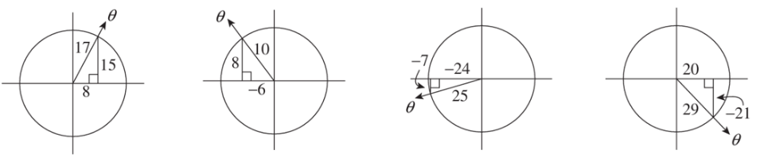  $$\sin{θ}=--\frac{21}{29}$$  $$\cos{θ}=-\frac{20}{29}$$  $$\tan{θ}=-\frac{21}{20}$$

- In each part, use Pythagoras’ theorem to find the unknown side of the right-angled triangle, then write down the values of $\sin{α},\cos{α},\tan{α}.$
$$\sin{α}=\frac{12}{13}$$  $$\cos{α}=\frac{5}{13}$$  $$\tan{α}=\frac{12}{5}$$ | $$\sin{α}=\frac{2}{3}$$  $$\cos{α}=-\frac{\sqrt{5}}{3}$$  $$\tan{α}=-\frac{2}{\sqrt{5}}$$ | $$\sin{α}=-\frac{3}{5}$$  $$\cos{α}=-\frac{4}{5}$$  $$\tan{α}=\frac{3}{4}$$ | 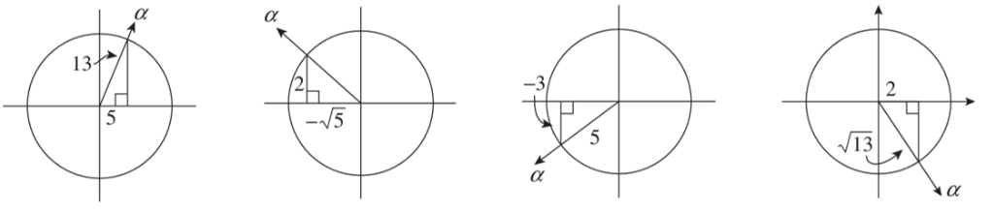  $$\sin{α}=-\frac{3}{\sqrt{13}}$$  $$\cos{α}=\frac{2}{\sqrt{13}}$$  $$\tan{α}=-\frac{3}{2}$$
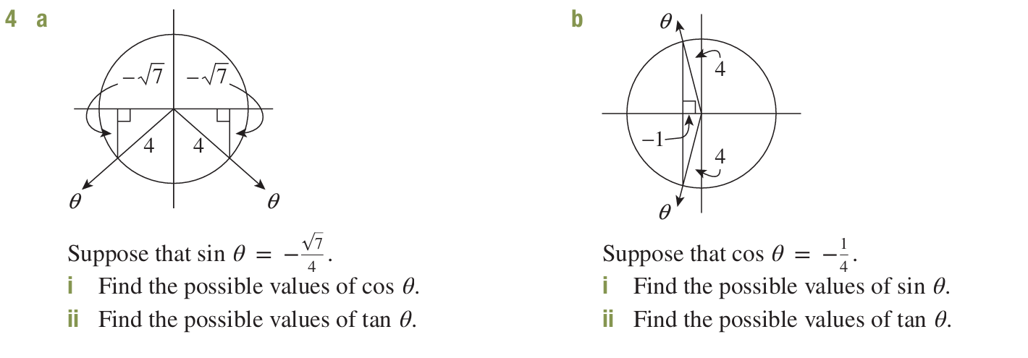

- Let $\sin{θ}=-\frac{\sqrt{7}}{4}$  Find the two possible values of $\cos{θ}$  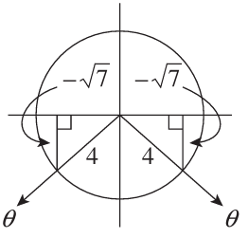  $$\cos{θ}=-\frac{3}{4} or\frac{3}{4}$$ | - Let $\cos{θ}=-\frac{1}{4}$  Find the two possible values of $\sin{θ}$  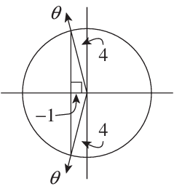  $$\sin{θ}=\frac{\sqrt{15}}{4} or-\frac{\sqrt{15}}{4}$$

Development
- For each question, draw a right-angled triangle using the given ratio, determine the quadrant(s), then find the new ratio.
- If $\cos{θ}=$ $\frac{1}{3}$ $,$  and $θ$ is acute,  Find $\tan{θ}$.  $$2\sqrt{2}$$ | - If $\cos{θ}=$ $-\frac{4}{5}$ $,$  and $θ$ is obtuse,  Find $\tan{θ}$.  $$-\frac{3}{4}$$ | - If $\cos{θ}=$ $\frac{1}{2}$ $,$  and $θ$ is reflex,  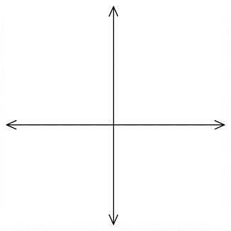  Find $\sin{θ}$.  $$-\frac{\sqrt{3}}{2}$$
- If $\tan{θ}=$ $-\frac{2}{3}$ $,$  and $θ$ is reflex,  Find $\cos{θ}$.  $$\frac{3}{\sqrt{13}}$$ | - If $\cos{θ}=$ $-\frac{40}{41}$ $,$  and $0°≤θ≤180°$ ,  Find $\sin{θ}$.  $$\frac{9}{41}$$ | - If $\sin{θ}=$ $\frac{1}{\sqrt{5}}$ $,$  and $-90°≤θ≤90°$,  Find $\tan{θ}$.  $$\frac{1}{2}$$

- For these questions, there are two possible answers.
- Find $\tan{θ},$  given $\cos{θ}=$ $-\frac{2}{3}$  $$±\frac{\sqrt{5}}{2}$$ | - Find $\tan{θ},$  given $\sin{θ}=$ $-\frac{12}{13}$  $$±\frac{12}{5}$$ | - Find $\cos{θ},$  given $\tan{θ}=$ $-\frac{2}{\sqrt{3}}$  $$±\frac{\sqrt{3}}{\sqrt{7}}$$

- If $\cos{α}=$ $\frac{4}{5}$ $,$  and $\sin{α}<0$,  Find $\tan{α}$.  $$-\frac{3}{4}$$ | - If $\tan{α}=$ $\frac{-8}{15}$ $,$  and $\sin{α}>0$,  Find $\cos{α}$.  $$-\frac{15}{17}$$ | - Find $\cos{α},$  given $\sin{α}=$ $\frac{1}{4}$  and $\tan{α}<0$.  $$-\frac{\sqrt{15}}{4}$$
- Find $\sin{θ},$  given $\tan{θ}=$ $\frac{35}{12}$  and $\cos{θ}>0$.  $$\frac{35}{37}$$ | - Find $\sec{θ},$  given $\operatorname{cosec}{θ}=$ $\frac{3}{2}$  and $θ$ is obtuse.  $$-\frac{3}{\sqrt{5}}$$ | - Find $\tan{θ},$  given $\sec{θ}=$ $-\frac{17}{8}$  and $0°≤θ≤180°$  $$-\frac{15}{8}$$
- If $\sin{A}=$ $-\frac{1}{3}$ $,$  and $\tan{A}<0$,  Find $\sec{A}$.  $$\frac{3\sqrt{2}}{4}$$ | - If $\operatorname{cosec}{B}=$ $\frac{7}{3}$ $,$  and $\cos{B}<0$,  Find $\tan{B}$.  $$-\frac{3\sqrt{10}}{20}$$ | - Find $\cot{θ},$  given $\sec{θ}=$ $-\sqrt{2}$  and $\operatorname{cosec}{θ}<0$  $$1$$

- Find the exact value of $\cot\left(-\frac{5π}{6}\right)$

Mastery
- Given $\cot{θ}=-\frac{24}{7}$ for $-\frac{π}{2}<θ<\frac{π}{2}$, find:
  - $\sec{θ}$

$$\frac{25}{4}$$
  - $\sin{θ}$

$$-\frac{7}{25}$$
- Given $\sec{θ}=-\frac{37}{12}$ for $0<θ<π$, find the exact value of $\operatorname{cosec}{θ}$

$$\frac{37}{35}$$
- If $\tan{α}=k$, where $k>0$, find the possible values of $\sin{α}$ and $\sec{α}$.
$α$ is in Q1 or 3
By drawing right-angled triangle,
$$opp=k, adj=1, hyp=\sqrt{k^{2}+1}$$
$\sin{α}=±$ $\frac{k}{\sqrt{1+k^{2}}}$
$$\sec{α}=±\sqrt{1+k^{2}}$$

- [$t$ formula]
  - Prove algebraically that ${\left(1-t^{2}\right)}^{2}+{\left(2t\right)}^{2}={\left(1+t^{2}\right)}^{2}$.
$$LHS=1-2t^{2}+t^{4}+4t^{2}$$
$$=1+2t^{2}+t^{4}$$
$={\left(1+t^{2}\right)}^{2}$
by recognising perfect square
  - If $\cos{x}=$ $\frac{1-t^{2}}{1+t^{2}}$, where $x$ is acute and $t$ is positive, find expressions for $\sin{x}$ and $\tan{x}$.

$$adj=1-t^{2}, hyp=1+t^{2}$$
using part a, $opp=2t$
$$\sin{x}=\frac{2t}{1+t^{2}}, \tan{x}=\frac{2t}{1-t^{2}}$$

- 2015 HSC Advanced Band 5
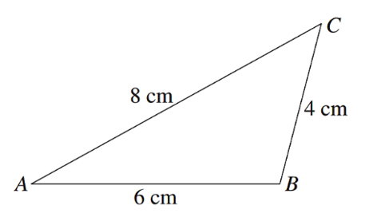
The diagram shows a non-right-angled triangle.
  - Show that $\cos{A}=$ $\frac{7}{8}$
$$\cos{A}=\frac{8^{2}+6^{2}-4^{2}}{2\left(8\right)\left(6\right)}=\frac{7}{8}$$

  - By finding the exact value of $\sin{A}$, determine the exact area of $ΔABC$.
By drawing a right-angled triangle,
$$opp=\sqrt{8^{2}-7^{2}}=\sqrt{15}$$
Since $A$ must be acute or obtuse, $\sin{A}=$ $\frac{\sqrt{15}}{8}$
$$A=\frac{1}{2}\left(8\right)\left(6\right)\left(\frac{\sqrt{15}}{8}\right)$$
$=3\sqrt{15}$ cm²

- If $a>0$ and $\sec{θ}=a+$ $\frac{1}{4a}$, prove that $\sec{θ}+\tan{θ}=2a or$ $\frac{1}{2a}$
$$\sec{θ}=\frac{4a^{2}+1}{4a}$$
$$\cos{θ}=\frac{4a}{4a^{2}+1}$$

$since a>0,\cos{θ}>0; θ$ is in Q1 or 4
$$adj=4a, hyp=4a^{2}+1$$
$$opp=\sqrt{{\left(4a^{2}+1\right)}^{2}-{\left(4a\right)}^{2}}=\sqrt{16a^{4}-8a^{2}+1}=\sqrt{{\left(4a^{2}-1\right)}^{2}}=4a^{2}-1$$

$$∴\tan{θ}=±\frac{4a^{2}-1}{4a}=±\left(a-\frac{1}{4a}\right)$$

$$\sec{θ}+\tan{θ}=a+\frac{1}{4a}+\left(a-\frac{1}{4a}\right)=2a$$
$$or \sec{θ}+\tan{θ}=a+\frac{1}{4a}-\left(a-\frac{1}{4a}\right)=\frac{1}{2a}$$

Solving Trigonometric Equations in Radians

- Solving Trigonometric Equations in Radians
If a question gives you the domain in radians, you are expected to give the solution in radians.
            - Find the acute reference angle using the inverse function on the calculator.
Remember to always use the positive ratio. $A=trig^{-1}\left(\left|value\right|\right)$
            - Determine the quadrants using ASTC based on the sign of the value.
            - Calculate $θ$ for each quadrant.

- Example Solve trigonometric equations in radians
Solve for $x∈\left[0,2π\right]$
$2\cos{x}+\sqrt{3}=0$
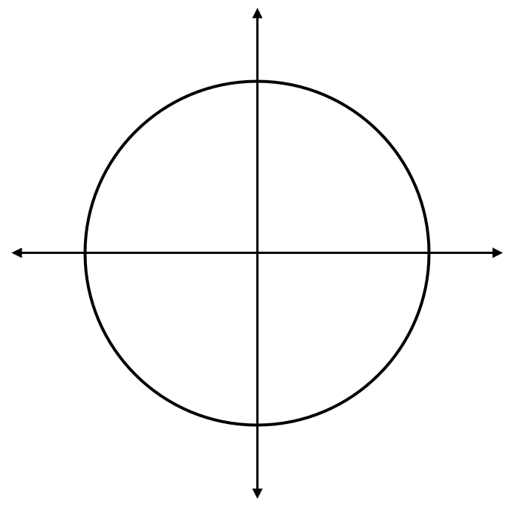
1. reference angle
$$\frac{π}{6}$$
$$\frac{π}{6}$$
$2\cos{x}=-\sqrt{3}$
$$\cos{x}=-\frac{\sqrt{3}}{2}$$
$$A=\cos^{-1}\left(\frac{\sqrt{3}}{2}\right)=\frac{π}{6}$$
2. quadrants
$\cos{x}<0$, $x$ is in Q2 or Q3
3. solutions
$∴x=$ $\frac{5π}{6}$ or $\frac{7π}{6}$

$\operatorname{cosec}{x}=-\sqrt{2}$
$$\frac{π}{4}$$
$$\frac{π}{4}$$
1. $\frac{1}{\sin{x}}=-\sqrt{2}$
$$\sin{x}=-\frac{1}{\sqrt{2}}$$
$$A=\sin^{-1}\left(\frac{1}{\sqrt{2}}\right)=\frac{π}{4}$$
2. $\sin{x}<0,$ $x$ is in Q3 or Q4
3. $∴x=$ $\frac{5π}{4}$ or $\frac{7π}{4}$

- Guided Practice
Solve for $x∈\left[0,2π\right]$.
- $\cos{x}=-$ $\frac{1}{2}$ | - $3-2\tan{x}=-3$
- $\tan{x}=3\cot{x}$ | - $\sin{x}\cos{x}=\sin{x}$

Foundation
- Solve, for the domain $x∈\left[0,2π\right)$.
- $\sin{x}=-1$  $$\frac{3π}{2}$$ | - $\cos{x}=\frac{1}{\sqrt{2}}$  $$\frac{π}{4},\frac{7π}{4}$$ | - $\cos{x}=1$  $$0, 2π$$
- $\tan{x}=\frac{1}{\sqrt{3}}$  $$\frac{5π}{6},\frac{11π}{6}$$ | - $\cos{x}=-\frac{1}{2}$  $$\frac{2π}{3},\frac{4π}{3}$$ | - $\tan{x}=-1$  $$\frac{3π}{4},\frac{7π}{4}$$

- Solve, for the domain $x∈\left[0,2π\right)$. Answer in radians to 3 d.p.
- $\sin{x}=0.316$  $$0.322,2.820$$ | - $2cos{x}=-0.689$  $$1.923,4.361$$ | - $\tan{x}=-\frac{3}{7}$  $$0.405,3.547$$

- Solve for $x∈\left[0,2π\right)$. Answer in exact form if possible, otherwise round to 3 d.p.
- $\cos{x}=\sec{x}$  $$0, π,2π$$ | - $\cos^{2}{x}=\cos{x}$  $$\frac{π}{2},\frac{3π}{2}, 0, 2π$$ | - $\left(2\sin{x}+1\right)\left(3\cos{x}-1\right)=0$  $$1.231, 5.052,\frac{7π}{6},\frac{11π}{6}$$
- $\tan{x}+3\cot{x}-4=0$  $$1.249, 4.391,\frac{π}{4},\frac{5π}{4}$$ | - $2\sin^{2}{x}+3\sin{x}-2=0$  $$\frac{π}{6},\frac{5π}{6}$$ | - $6\sin{x}\cos^{2}{x}-2\sin{x}=0$  $$0, π, 2π, 0.955, 2.186, 4.097, 5.328$$

Trigonometric Equations in Any Domain

- Solving Trigonometric Equations (Any Domain)
A non-standard domain is a domain that is not $0≤θ<360°$
- Find the acute reference angle using a calculator.
Always use the positive ratio to find the reference angle.
- Determine the quadrants of the solutions using ASTC.
- Find the solutions in $\left[0°,360°\right)$ using the quadrants.
- Find solutions in domain by adding/subtracting 360°

- Example Solve simple trigonometric equations in any domain
Solve $\sin{x}=-\frac{1}{2}$ for $-180°≤x≤180°$
1. reference angle
$$30°$$
$$30°$$
$$x=\sin^{-1}\left(\frac{1}{2}\right)=30°$$
2. quadrants
$\sin{x}<0, x$ is in Q3 or 4.
3. solutions
$x=210°$ or $330°$
4. domain
subtract $360°$ from both solutions
$x=-150°$ or $-30°$
Solve $\sec{θ}=2$ for $0°≤θ≤720°$
$$60°$$
$$60°$$
$$1. \frac{1}{\cos{θ}}=2$$
$$\cos{θ}=\frac{1}{2}$$
$$θ=\cos^{-1}\left(\frac{1}{2}\right)=60°$$
2. $\cos{θ}>0,$ $θ$ is in Q1 or 4.
3. $x=60°$ or $300°$
4. add $360°$ to get more solutions
$$x=60°, 300°,420°,660°$$

- Guided Practice
- Solve $\tan{x}=\sqrt{3}$ for $-180°≤x≤180°$  $$60°, -120°$$ | - Solve $\sin{x}=-$ $\frac{1}{2}$ for $0°≤x≤720°$  $$210°, 330°, 570°, 690°$$
- Solve $\cot{x}=-\sqrt{3}$ for $-180°≤x≤180°$  $$150°, -30°$$ | - Solve $\operatorname{cosec}{x}=$ $\sqrt{2}$ for $0°≤x≤720°$  $$45°, 135°, 405°, 495°$$

Foundation
- Solve for $-180°≤x≤180°$. Give solutions to the nearest minute where necessary.
- $\sin{θ}=$ $\frac{1}{2}$  $$30°, 150°$$ | - $\tan{θ}=1$  $$45°, -135°$$ | - $\tan{θ}=-$ $\frac{1}{\sqrt{3}}$  $$150°, -30°$$ | - $\cos{θ}=-$ $\frac{\sqrt{3}}{2}$  $$150°, -150°$$
- $\tan{θ}=-0.3$  $$-16°{42}^{'}, 163° 18'$$ | - $\cos{x}=0$  $$90°, -90°$$ | - $\sec{θ}=\sqrt{2}$  $$45°, -45°$$ | - $\sin{θ}=-0.7$  $$-135°34', -44°26'$$

- Solve for $0°≤θ≤720°$.
- $2\cos{θ}-1=0$  $$60°, 300°, 420°, 660°$$ | - $\cot{θ}=0$  $$90°, 270°, 450° , 630°$$ | - $\operatorname{cosec}{θ}+2=0$  $$210°, 330°, 570°, 690°$$ | - $\tan{θ}=\sqrt{2}-1$  $$22°{30}^{'},202°{30}^{'},382°{30}^{'}, 562°30'$$

- Consider the trigonometric graphs sketched in the domain $-2π≤θ≤2π$.
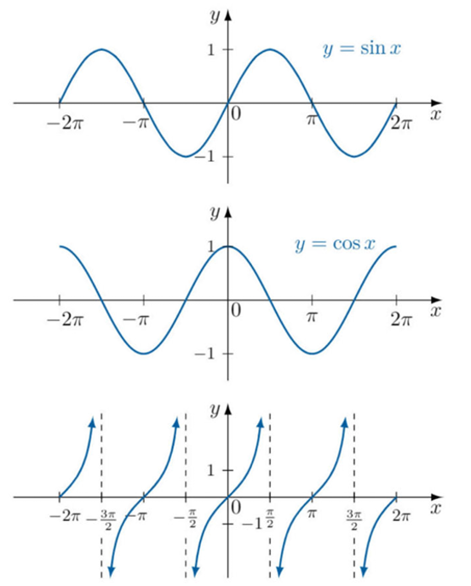
Use the graphs to solve:
  - $\sin{θ}=0$

$$0, ±π,± 2π$$
  - $\sin{θ}=1$

$$-\frac{3π}{2},\frac{π}{2}$$
  - $\cos{θ}=-1$

$$±π$$
  - $\tan{θ}=0$

$$0, ±π, ±2π$$

- The graph of $y=\sin{x}$ and $y=$ $\frac{1}{\sqrt{2}}$ have been sketched in the domain $-2π≤θ≤2π$.
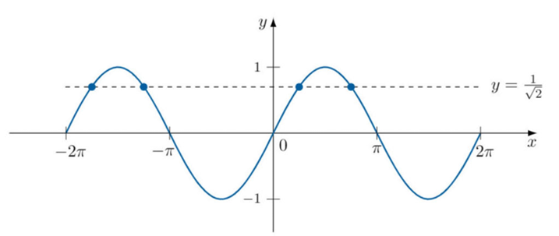
  - How many solutions to $\sin{x}=$ $\frac{1}{\sqrt{2}}$ are there in this domain? Explain how you know from the graphs.

4 points of intersection, so 4 solutions.

  - Find the exact solutions of $x$ in this domain.

$$-\frac{7π}{4}, -\frac{5π}{4},\frac{π}{4},\frac{3π}{4}$$

- Solve $\sin{θ}=$ $\frac{1}{2}$ in the domain $x∈[0, 4π]$

$$\frac{π}{6},\frac{5π}{6},\frac{13π}{6},\frac{17π}{6}$$

Trigonometric Equations with Compound Angles

- Solving Trigonometric Equations (Compound Angles)
A compound angle is where the angle inside the trigonometric function is a sum or product.
E.g. $\sin{(x+90°})$ or $\cos{(2x});$ $x+90°$ and $2x$ are the compound angles.
- Let $u$ be the compound angle.
- Determine the domain for $u$.
- Solve the trigonometric equation for $u$.
- Substitute to solve for $x$.

- Example Solve trigonometric equations involving compound angles
Solve $\tan{2x}=\sqrt{3}$ for $0≤x≤360°$
1. Let $u=2x$
2. $0≤2x≤720°$
$0≤u≤720°$
3. $\tan{u}=\sqrt{3}$
$$60°$$
$$60°$$
$u=\tan^{-1}{\sqrt{3}}$
$=60°$
$\tan{u}>0,$ $u$ is in quadrant 1 or 3.
$u=60°, 240°, 420°, 600°$
4.
$$\frac{x}{2}=60°, 240°, 420°, 600°$$
$x=30°,120°,210°,300°$

- Guided Practice
- Solve $\sin{2x}=-\frac{\sqrt{3}}{2}$ for $0≤x≤360°$

- Solve $\sin{(x-90°})=\frac{\sqrt{3}}{2}$ for $-180°≤x≤180°$

Foundation
- Consider $\sin{2θ=}$ $\frac{1}{2}$ in the domain $θ∈\left[0°, 360°\right]$.
  - If $u=2θ$, then $u∈[ , ]$
$$\left[0, 720°\right]$$
  - The equation to solve is now
$$\sin{____}=\frac{1}{2}$$
$$\sin{u}=\frac{1}{2}$$
  - Solving this in the domain from a,
$u=30°, 150°$, ………°, ………°
$$30°, 150°, 390°, 510°$$
  - Hence, the solutions are:
$2θ=30°, 150°$, ………, ………
$$30°, 150°, 390°, 510°$$
$θ=$ ………, ………, ………, ………
$$15°, 75°, 195°, 255°$$
- Solve for $0°≤x≤360°$.
- $\sin{2x}=$ $\frac{1}{2}$  $$15°,75°, 195°, 255°$$ | - $\tan{2x}=\sqrt{3}$  $$30°, 120°, 210°, 300°$$ | - $\cos{2x}=-$ $\frac{1}{\sqrt{2}}$  $$67°{30}^{'}, 112° {30}^{'},247°{30}^{'}, 292°30'$$
- $\sin{2x}=-1$  $$135°, 315°$$ | - $\sin{2x}=$ $\frac{1}{2}$  $$15°,75°, 195°, 255°$$ | - $\sin{\frac{x}{2}}=-$ $\frac{1}{2}$  No solution
- $\cos{3θ}=$ $\frac{1}{\sqrt{2}}$  $$15°, 105°, 135°, 225°, 255°, 345°$$ | - $\tan\left(x-45°\right)=$ $\frac{1}{\sqrt{3}}$  $$75°,255°$$ | - $\sin\left(x+30°\right)=$ $\frac{\sqrt{3}}{2}$  $$30°,90°$$
- $\cos{(x+60°})=1$  $$300°$$ | - $\sin\left(α-75°\right)=-$ $\frac{1}{\sqrt{2}}$  $$300°, 30°$$ | - $\tan\left(x+210°\right)=-\sqrt{3}$  $$90°,270°$$

- Solve for $0°≤θ<360°$.
- $\sin\left(2θ-60°\right)=1$  $$75°, 255°$$ | - $\cos{(3θ+45°)}=-$ $\frac{1}{\sqrt{2}}$  $$30°, 60°, 150°, 180°, 270°, 300°$$
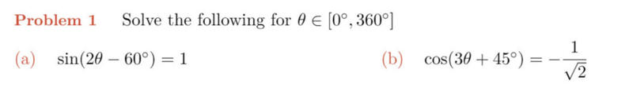

Ratio and Reciprocal Trigonometric Identities

- Ratio and Reciprocal Trigonometric Identities
We use these identities to simplify expressions.
It is generally a good idea to write everything in terms of sin and cos.
Reciprocal Trig Identities  $$\operatorname{cosec}{θ}=\frac{1 }{sin θ}, \sin{θ≠0} \\ \sec{θ}=\frac{1}{cos θ}, \cos{θ}≠0 \\ \cot{θ}=\frac{1}{tan θ}, \sin{θ}≠0$$ | Ratio Identities  $$\tan{θ}=\frac{\sin{θ}}{\cos{θ}}$$  $$\cot{θ}=\frac{\cos{θ}}{\sin{θ}}$$

- Example Simplify expressions using the ratio and reciprocal identities
Worked example | Your Turn
Simplify $\tan{θ}\operatorname{cosec}{θ}$  $$\tan{θ}\operatorname{cosec}{θ}=\frac{\sin{θ}}{\cos{θ}}×\frac{1}{\sin{θ}}$$  $=$ $\frac{1}{\cos{θ}}$  $=\sec{θ}$ | Simplify $\sec{θ}\cot{θ}$  $$\operatorname{cosec}{θ}$$

- Proving Identities
Prove an identity by algebraically manipulating one of the sides to match the other.
You CANNOT apply operations to both sides when proving statements.

- Example Prove trigonometric identities using the ratio and reciprocal identities
Worked Example | Your Turn
Prove $\sin{θ}\cot{θ}=\cos{θ}$  $$LHS=\sin{θ}\cot{θ} \\ =\sin{θ}× \frac{\cos{θ}}{\sin{θ}} \\ =\cos{θ}=RHS$$ | Prove $\sin{A}\sec{A}=\tan{A}$

Foundation
- Simplify
- $\sin{α}\operatorname{cosec}{α}$  1 | - $\cot{β}\tan{β}$  1 | - $\cos{θ}\sec{θ}$  1
- $\frac{1}{\sec^{2}{θ}}$  $$\cos^{2}{θ}$$ | - $\frac{\sin^{2}{β}}{\cos^{2}{β}}$  $$\tan^{2}{β}$$ | - $\frac{\cos^{2}{β}}{\sin^{2}{β}}$  $$\cot^{2}{β}$$
- $\frac{\cos{α}}{\sec{α}}$  $$\cos^{2}{α}$$ | - $\frac{\sin{α}}{\operatorname{cosec}{α}}$  $$\sin^{2}{α}$$ | - $\frac{\tan{A}}{\sec{A}}$  $$\sin{A}$$

- Prove:
- $\tan{θ}\cos{θ}=\sin{θ}$ | - $\cot{α}\sin{α}=\cos{α}$ | - $\sin{β}\sec{β}=\tan{β}$
- $\cos{A}\operatorname{cosec}{A}=\cot{A}$ | - $\operatorname{cosec}{x} \cos{x} \tan{x}=1$ | - $\sin{y} \cot{y} \sec{y}=1$

Pythagorean Trigonometric Identities

- The Pythagorean Identity
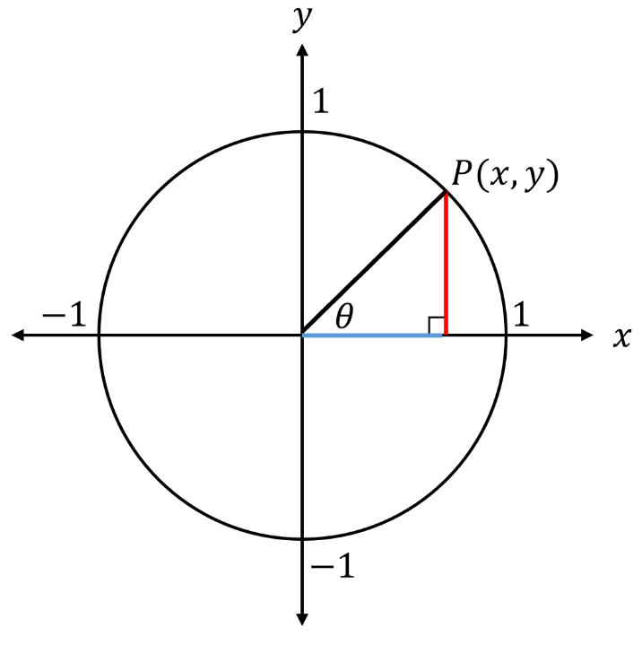
Consider a unit circle centred at the origin.

Using $x=\cos{θ}$ and $y=\sin{θ}$, we can use
Pythagoras’ Theorem to write an equation.

$x^{2} + y^{2} =1$

………… $+$ ………… $=1$
This is called the Pythagorean Identity

We can use it to derive other identities:

Divide both sides by $\cos^{2}{θ}$ $\cos^{2}{θ} + \sin^{2}{θ} =1$

………… $+$ ………… $=$ …………

Divide both sides by $\sin^{2}{θ}$ $\cos^{2}{θ} + \sin^{2}{θ} =1$

………… $+$ ………… $=$ …………

- The Pythagorean Identities
$$\sin^{2}{θ}+\cos^{2}{θ}=1 \\ \sin^{2}{θ}=1-\cos^{2}{θ} \\ \cos^{2}{θ}=1-\sin^{2}{θ}$$ | $$\sec^{2}{θ}=\tan^{2}{θ}+1 \\ \tan^{2}{θ}=\sec^{2}{θ}-1$$ | $${cosec}^{2}{θ}=\cot^{2}{θ}+1 \\ \cot^{2}{θ}={cosec}^{2}{θ}-1$$

- Example Prove trigonometric identities using the ratio and reciprocal identities
Worked Example | Your Turn
Simplify $5\cot^{2}{θ}+5$  $=5\left(\cot^{2}{θ}+1\right)$  $=5{cosec}^{2}{θ}$ | Simplify $\cot{θ}-\cot{θ}\cos^{2}{θ}$  $$sin θ\cos{θ}$$

Foundation
- Simplify using the Pythagorean identities
- $\sin^{2}{α}+\cos^{2}{α}$  1 | - $1-\cos^{2}{β}$  $$\sin^{2}{β}$$ | - $1+\tan^{2}{ϕ}$  $$\sec^{2}{ϕ}$$
- $\sec^{2}{x}-\tan^{2}{x}$  1 | - $1-\sin^{2}{β}$  $$\cos^{2}{β}$$ | - $1+\cot^{2}{ϕ}$  $${cosec}^{2}{ϕ}$$
- $cosec^{2}A-1$  $$\cot^{2}{A}$$ | - $\cot^{2}{θ}-{cosec}^{2}{θ}$  $$-1$$

- Simplify using the Pythagorean identities
- $\sin^{2}{θ}{cosec}^{2}{θ}$  1 | - $\cot^{2}{θ}-{cosec}^{2}{θ}$  $$-1$$ | - $\tan^{2}{θ}-$ $\frac{1}{\cos^{2}{θ}}$  $$-1$$
- $\sin^{2}{θ}-\sin^{2}{θ}\cos^{2}{θ}$  $$\sin^{4}{θ}$$ | - $\sin^{4}{θ}-\cos^{4}{θ}$  $$\sin^{2}{θ}-\cos^{2}{θ}$$ | - ${\left(\sin{θ}+\cos{θ}\right)}^{2}$  $$1+2\sin{θ}\cos{θ}$$
- $1-\tan^{2}{θ}+\sec^{2}{θ}$  2 | - $\tan^{2}{θ}\cos^{2}{θ}+\cot^{2}{θ}\sin^{2}{θ}$  1

Trigonometric Identity Proofs

- Trigonometric Identities
Cofunction Identities
$$\sin{θ}=\cos{(90°-θ)} \\ \cos{θ}=\sin{(90°-θ)}$$ | $$\sec{θ}=cosec \left(90°-θ\right) \\ cosec θ=\sec\left(90°-θ\right)$$ |  | $$\tan{θ}=\cot{(90°-θ}) \\ \cot{θ}=\tan{(90°-θ})$$
Reciprocal Trig Identities  $$\operatorname{cosec}{θ}=\frac{1 }{sin θ}, \sin{θ≠0} \\ \sec{θ}=\frac{1}{cos θ}, \cos{θ}≠0 \\ \cot{θ}=\frac{1}{tan θ}, \sin{θ}≠0$$ |  | Ratio Identities  $$\tan{θ}=\frac{\sin{θ}}{\cos{θ}}$$  $$\cot{θ}=\frac{\cos{θ}}{\sin{θ}}$$
Pythagorean Identities
$$\sin^{2}{θ}+\cos^{2}{θ}=1 \\ \sin^{2}{θ}=1-\cos^{2}{θ} \\ \cos^{2}{θ}=1-\sin^{2}{θ}$$ | $$\sec^{2}{θ}=\tan^{2}{θ}+1 \\ \tan^{2}{θ}=\sec^{2}{θ}-1$$ |  | $${cosec}^{2}{θ}=\cot^{2}{θ}+1 \\ \cot^{2}{θ}={cosec}^{2}{θ}-1$$
Tips for proving identities
- You CANNOT apply operations to both sides when proving statements.
- Convert to sine and cosine: Simplify mixed functions by rewriting everything in terms of sinθ and cosθ.
- Use Pythagorean identities: Replace squared terms using the identities
- Start with the more complex side: It gives more options for simplification.
- Expand brackets: Reveals terms that may cancel or combine.
- Factor expressions: Useful when one side is a product and the other a sum or difference.
- Split fractions: Break up a single fraction into separate terms if the other side has multiple terms.
- Combine fractions: Use a common denominator to merge terms.
- Multiply by the conjugate: For expressions with binomials in the denominator, this can reveal a difference of two squares.
- Simplify both sides: Complex examples will require you to simplify both LHS and RHS separately until they match.
- There can be more than one way to prove an identity. If your solution does not match the provided solutions, it is likely correct if you have followed the rules for proving identities.

The key is recognising patterns through practice. You will likely struggle at first.

- Guided Practice
Prove $\cot{x}+\tan{x}=\operatorname{cosec}{x}\sec{x}$ | Prove $cosec^{2}θ+\sec^{2}{θ}=\sec^{2}{θ}{cosec}^{2}{θ}$
Prove $\frac{1-\cos{x}}{\sin^{2}{x}}=\frac{1}{1+\cos{x}}$ | Prove $\frac{\cos{θ}}{1-\sin{θ}}$ $-\tan{θ}=\sec{θ}$

Foundation
- Prove:
- $(1-sinθ)(1+sinθ)=cos²θ$  LHS  = 1² − sin² θ  = 1 − sin² θ  = cos² θ  = RHS | - $\left(1+\tan^{2}α\right)cos²α=1$  LHS  = sec² αcos² α  $$= \left(\frac{1}{cos^{2} α}\right)cos² α$$  = 1  = RHS
- ${\left(sinA+cosA\right)}^{2}=1+2 sinA cosA$  LHS  = sin² A + 2 sin A cos A + cos² A  = (sin² A + cos² A) + 2 sin A cos A  = 1 + 2 sin A cos A  = RHS | - $\cos^{2}x-\sin^{2}x=1-2sin²x$  RHS  = (sin² x + cos² x) − 2 sin² x  = cos² x − sin² x  = LHS
- $\tan^{2}φ \cos^{2}φ+\cot^{2}φ sin²φ=1$  LHS  $$= \left(\frac{\sin^{2}φ}{\cos^{2}φ}\right)cos² φ + \left(\frac{\cos^{2}φ}{\sin^{2}φ}\right)sin² φ$$  = sin² φ + cos² φ  = 1  = RHS | - $3cos²θ-2=1-3sin²θ$  RHS  = 1 − 3(1 − cos² θ)  = 1 − 3 + 3 cos² θ  = 3 cos² θ − 2  = LHS
- $2\tan^{2}A-1=2\sec^{2}A -3$  RHS  = 2(1 + tan² A) − 3  = 2 + 2 tan² A − 3  = 2 tan² A − 1  = LHS | - $1-\tan^{2}α+\sec^{2}α=2$  LHS  =1 − tan² α + sec² α  = 1 − tan² α + (1 + tan² α)  = 2  = RHS
- $\cos^{4}x+\cos^{2}x \sin^{2}x=\cos^{2}x$  LHS  = cos² x (cos² x + sin² x)  = cos² x · 1  = cos² x  = RHS | - $cotθ (\sec^{2}θ-1)=tanθ$  LHS  = cot θ · tan² θ  $$= \left(\frac{1}{tanθ}\right)tan² θ$$  = tan θ  = RHS
- $2 cos² θ - 1 = 1 - 2 sin² θ$  LHS  = 2 cos² θ − (sin² θ + cos² θ)  = 2 cos² θ − sin² θ − cos² θ  = cos² θ − sin² θ  = (1 − sin² θ) − sin² θ  = 1 − 2 sin² θ  = RHS | - $tan θ sin θ + cos θ = sec θ$  LHS  $$=\frac{sin θ}{cos θ} · sin θ + cos θ$$  $$=\frac{sin^{2}θ}{cos θ} + cos θ$$  $$=\frac{sin^{2}θ + cos^{2}θ}{cos θ}$$  $$=\frac{1}{cos θ}$$  = sec θ  = RHS

Development
- Prove:
- $tanα cosecα=secα$  LHS  $$=\frac{\sin{α}}{\cos{α}}·\left(\frac{1}{\sin{α}}\right)$$  $$=\frac{1}{\cos{α}}$$  = sec α  = RHS | - $cotβ secβ=cosecβ$  LHS  $$=\frac{cos β}{sin β} · \left(\frac{1}{\cos{β}}\right)$$  $$=\frac{1}{\sin{β}}$$  = cosec β  = RHS
- ${cosec}^{2}γ+\sec^{2}γ={cosec}^{2}γsec²γ$  LHS  $$=\frac{1}{\sin^{2}γ} +\frac{1}{\cos^{2}γ}$$  $$=\frac{\cos^{2}γ + \sin^{2}γ}{\sin^{2}γ \cos^{2}γ}$$  $$=\frac{1}{\sin^{2}γ \cos^{2}γ}$$  $$= \left(\frac{1}{\sin^{2}γ}\right)\left(\frac{1}{\cos^{2}γ}\right)$$  = cosec² γ sec² γ  = LHS | - $tanδ+cotδ=cosecδ secδ$  LHS  $$=\frac{sin δ}{cos δ} +\frac{\cos{δ}}{\sin{δ}}$$  $$=\frac{sin^{2}δ + cos^{2}δ}{sin δ cos δ}$$  $$=\frac{1}{sin δ cos δ}$$  $$= \left(\frac{1}{\sin{δ}}\right) · \left(\frac{1}{\cos{δ}}\right)$$  = cosec δ sec δ  = RHS
- $cosecφ-sinφ=cosφ cotφ$  LHS  $$=\frac{1}{\sin{φ}} - sin φ$$  $$=\frac{1 - sin^{2}φ}{sinφ}$$  $$=\frac{cos^{2}φ}{sin φ}$$  $$= cos φ ·\frac{cos φ}{sin φ}$$  = cos φ cot φ  = RHS | - $secθ-cosθ=tanθ sinθ$  LHS  $$=\frac{1}{\cos{θ}} - cos θ$$  $$=\frac{1 - cos^{2}θ}{\cos{θ}}$$  $$=\frac{sin^{2}θ}{cos θ}$$  $$= sin θ ·\frac{sin θ}{cos θ}$$  = sin θ tan θ  = RHS
$$\frac{1}{sin θ cos θ} - tan θ = cot θ$$  LHS  $$=\frac{1}{sin θ cos θ}-\frac{sin θ}{cos θ}$$  $$=\frac{1 - sin^{2}θ}{sin θ cos θ}$$  $$=\frac{cos^{2}θ}{sin θ cos θ}$$  $$=\frac{cos θ}{sin θ}$$  = cot θ  = RHS | - $tan θ(1-cot² θ) + cot θ(1-tan² θ)=0$  LHS  = tan θ − tan θ cot² θ + cot θ − cot θ tan² θ  $$= tan θ - tan θ · \left(\frac{1}{tan^{2}θ}\right) + cot θ - cot θ · tan² θ$$  $$= tan θ -\frac{1}{tan θ} + cot θ -\frac{tan^{2}θ}{tan θ}$$  = tan θ − cot θ + cot θ − tan θ  = 0  = RHS

- Prove:
- $sin θ cos θ cosec² θ = cot θ$  LHS  $$= sin θ cos θ · \left(\frac{1}{sin^{2}θ}\right)$$  $$= \frac{\cos{θ}}{sin θ}$$  = cot θ  = RHS | - $(cos φ + cot φ) sec φ = 1 + cosec φ$  LHS  = cos φ sec φ + cot φ sec φ  $$= cos φ·\left(\frac{1}{\cos{φ}}\right) + \left(\frac{\cos{φ}}{\sin{φ}}\right)·\left(\frac{1}{cos}φ\right)$$  $$= 1 +\frac{1}{sin φ}$$  = 1 + cosec φ  = RHS
- $sin⁴ A - cos⁴ A = sin² A - cos² A$  LHS  = (sin² A)² − (cos² A)²  = (sin² A − cos² A)(sin² A + cos² A)  = (sin² A − cos² A) · 1  = sin² A − cos² A  = RHS | - $sin β + cot β cos β = cosec β$  LHS  $$= sin β +\frac{cos β}{sin β} ·cos β$$  $$= sin β +\frac{cos^{2}β}{sin β}$$  $$=\frac{sin^{2}β + cos^{2}β}{sin β}$$  $$=\frac{1}{sin β}$$  = cosec β  = RHS
$$\frac{1 + \tan^{2}x}{1 + \cot^{2}x} = tan² x$$  LHS  $$=\frac{sec^{2}x}{cosec^{2}x}$$  $$=\frac{\left(\frac{1}{cos^{2}x}\right)}{\left(\frac{1}{sin^{2}x}\right)}$$  $$=\frac{sin^{2}x}{cos^{2}x}$$  = tan² x  = RHS | $$\frac{1 + cot x}{1 + tan x} = cot x$$  LHS  $$=\frac{\left(1 +\frac{cos x}{sin x}\right)}{\left(1 +\frac{sin x}{cos x}\right)}$$  $$=\frac{\left(\frac{sin x + cos x}{sin x}\right)}{\left(\frac{cos x + sin x}{cos x}\right)}$$  $$= \frac{sin x + cos x}{\sin{x}} · \frac{\cos{x}}{cos x + sin x}$$  $$= \frac{cos x}{\sin{x}}$$  = cot x  = RHS
$$\frac{1}{1 + sin θ} +\frac{1}{1 - sin θ} = 2 sec² θ$$  LHS  $$=\frac{1 - sin θ + 1 + sin θ}{\left(1 + sin θ\right)\left(1 - sin θ\right)}$$  $$=\frac{2}{1 - sin^{2}θ}$$  $$=\frac{2}{cos^{2}θ}$$  = 2 sec² θ  = RHS | $$\frac{1}{sec φ - tan φ} -\frac{1}{sec φ + tan φ} = 2 tan φ$$  LHS  $$=\frac{sec φ + tan φ - sec φ + tan φ}{\left(sec φ - tan φ\right)\left(sec φ + tan φ\right)}$$  $$=\frac{2 tan φ}{sec^{2}φ - tan^{2}φ}$$  $$=\frac{2 tan φ}{1}$$  = 2 tan φ  = RHS

$$\frac{1 + cos θ}{sin^{2}θ} =\frac{1}{1 - cos θ}$$  LHS =  $$= \frac{1 + cos θ}{1 - cos^{2}θ}$$  $$= \frac{1 + cos θ}{\left(1 - cos θ\right)\left(1 + cos θ\right)}$$  $$=\frac{1}{1 - cos θ}$$  = RHS | $$\frac{cos^{2}θ}{1 + sin θ} +\frac{cos^{2}θ}{1 - sin θ} = 2$$  LHS =  $$= \cos^{2}θ \frac{1 - sin θ + 1 + sin θ}{\left(1 + sin θ\right)\left(1 - sin θ\right)}$$  $$= cos² θ · \frac{2}{1 - sin^{2}θ}$$  $$= cos² θ · \frac{2}{cos^{2}θ}$$  = 2  = RHS
- $tan² θ cos θ = sec θ - cos θ$  $$RHS = sec θ - cos θ$$  $$=\frac{1}{cos θ} - cos θ$$  $$=\frac{1 - cos^{2}θ}{cos θ}$$  $$=\frac{sin^{2}θ}{cos θ}$$  $$=\frac{sin^{2}θ}{cos^{2}θ} · cos θ$$  $$= tan² θ cos θ$$  $$= LHS$$ | - $sec⁴ θ - tan⁴ θ = 2 sec² θ - 1$  LHS =  = (sec² θ)² − (tan² θ)²  = (sec² θ − tan² θ)(sec² θ + tan² θ)  = 1 · (sec² θ + tan² θ)  = sec² θ + tan² θ  = sec² θ + (sec² θ − 1)  = 2 sec² θ – 1  = RHS
$$\frac{cosec θ +\sec{θ}}{1 + tan θ} = cosec θ$$  LHS =  $$=\frac{\frac{1}{sin θ}+\frac{1}{cos θ}}{1 +\frac{sin θ}{cos θ}}$$  $$=\frac{\left(\frac{cos θ + sin θ}{sin θ cos θ}\right)}{\left(\frac{cos θ + sin θ}{\cos{θ}}\right)}$$  $$= \frac{cos θ + sin θ}{sin θ cos θ} · \frac{cos θ}{cos θ + sin θ}$$  $$= \frac{cos θ}{sin θ cos θ}$$  $$=\frac{1}{sin θ}$$  = cosec θ  = RHS | $$\frac{1}{1 + sin^{2}θ} +\frac{1}{1 + cosec^{2}θ} = 1$$  LHS =  $$=\frac{1}{1 + sin^{2}θ} +\frac{1}{1 +\frac{1}{sin^{2}θ}}$$  $$=\frac{1}{1 + sin^{2}θ} +\frac{1}{\frac{sin^{2}θ + 1}{sin^{2}θ}}$$  $$=\frac{1}{1 + sin^{2}θ} +\frac{sin^{2}θ}{1 + sin^{2}θ}$$  $$=\frac{1 + sin^{2}θ}{1 + sin^{2}θ}$$  = 1  = RHS
$$\frac{cot^{2}θ - 1}{cot^{2}θ + 1} = 1 - 2 sin² θ$$  LHS =  $$=\frac{cot^{2}θ - 1}{cosec^{2}θ}$$  $$=\frac{\frac{cos^{2}θ}{sin^{2}θ} - 1}{\frac{1}{sin^{2}θ}}$$  $$= sin^{2}θ ·\frac{cos^{2}θ - sin^{2}θ}{sin^{2}θ}$$  = cos² θ − sin² θ  = (1 − sin² θ) − sin² θ  = 1 − 2 sin² θ  = RHS | $${\left(sec θ + tan θ\right)}^{2}=\frac{1 + sin θ}{1 - sin θ}$$  LHS =  $$= \left(\frac{1}{cos θ}+\frac{sin θ}{cos θ}\right)²$$  $$= \left(\frac{1 + sin θ}{\cos{θ}}\right)²$$  $$=\frac{{\left(1 + sin θ\right)}^{2}}{cos^{2}θ}$$  $$=\frac{{\left(1 + sin θ\right)}^{2}}{1 - sin^{2}θ}$$  $$=\frac{{\left(1 + sin θ\right)}^{2}}{\left(1 - sin θ\right)\left(1 + sin θ\right)}$$  $$=\frac{1 + sin θ}{1 - sin θ}$$  = RHS

Mastery
- [Parametrisation of a circle]
The coordinates of a relation are given by: $x=a cos θ and y=a sin θ$,
show that this is can represented by the relation $x^{2}+y^{2}=a^{2}$
(Hint: use the Pythagorean identity)

$$\cos{θ}=\frac{x}{a},\sin{θ}=\frac{y}{a}$$
$$using\cos^{2}{θ}+\sin^{2}{θ}=1$$
$$\frac{x^{2}}{a^{2}}+\frac{y^{2}}{a^{2}}=1$$
$$∴x^{2}+y^{2}=a^{2}$$
- For each $x$ and $y$, find an equation relating $x$ and $y$ that is independent of $θ$.
Use the method in the previous question.
- $x=a\cos{θ} and$  $$y=a sin θ$$  $$cos θ =\frac{x}{a}, sin θ =\frac{y}{b}$$  Using cos² θ + sin² θ = 1:  $$\frac{x^{2}}{a^{2}} +\frac{y^{2}}{b^{2}} = 1$$ | - $x=a\tan{θ} and$  $$y=b sec θ$$  $$tan θ =\frac{x}{a}, sec θ =\frac{y}{b}$$  Using sec² θ - tan² θ = 1:  $$\frac{y^{2}}{b^{2}} -\frac{x^{2}}{a^{2}} = 1$$ | - $x=2+\cos{θ} and$  $$y=1+sin θ$$  cos θ = x - 2, sin θ = y - 1  Using cos² θ + sin² θ = 1:  (x - 2)² + (y - 1)² = 1

- Show that these expressions are independent of $θ$.
- $\frac{cos^{2}θ}{1 + sin θ} +\frac{cos^{2}θ}{1 - sin θ}$  $$= cos^{2}θ ·\frac{\left(1 - sin θ + 1 + sin θ\right)}{\left(1 + sin θ\right)\left(1 - sin θ\right)}$$  $$= cos^{2}θ ·\frac{2}{\left(1 - sin^{2}θ\right)}$$  $$= cos^{2}θ ·\frac{2}{cos^{2}θ}$$  $$= 2$$ | - $tan θ(1 - cot² θ) + cot θ(1 - tan² θ)$  $$= tan θ - tan θ · cot² θ + cot θ - cot θ · tan² θ$$  $$= tan θ - tan θ ·\frac{1}{tan^{2}θ} + cot θ - cot θ · tan² θ$$  $$= tan θ -\frac{1}{tan θ} + cot θ -\frac{tan^{2}θ}{tan θ}$$  $$= tan θ - cot θ + cot θ - tan θ$$  $$= 0$$
- $\frac{tan θ + cot θ}{sec θ cosec θ}$  $$=\frac{\frac{sin θ}{cos θ} +\frac{cos θ}{sin θ}}{\frac{1}{cos θ}·\frac{1}{sin θ}}$$  $$=\frac{\frac{sin^{2}θ + cos^{2}θ}{sin θ cos θ}}{\frac{1}{sin θ cos θ}}$$  $$= \left(\frac{sin^{2}θ + cos^{2}θ}{sin θ cos θ}\right)· \left(sin θ cos θ\right)$$  $$= sin² θ + cos² θ$$  $$= 1$$ | - $\frac{tan θ + 1}{\sec{θ}} -\frac{cot θ + 1}{cosec θ}$  $$=\frac{\frac{sin θ}{cos θ}+ 1}{\frac{1}{cos θ}}-\frac{\frac{cos θ}{sin θ}+ 1}{\frac{1}{sin θ}}$$  $$=\frac{sin θ + cos θ}{cos θ}· cos θ -\frac{cos θ + sin θ}{sin θ} · sin θ$$  $$= sin θ + cos θ - (cos θ + sin θ)$$  $$= sin θ + cos θ - cos θ - sin θ$$  $$= 0$$
- Prove:

$$\frac{2 \cos^{3}θ - cos θ}{sin θ \cos^{2}θ - \sin^{3}θ} = cot θ$$
LHS =
$$=\frac{cos θ\left(2 \cos^{2}θ - 1\right)}{sin θ\left(\cos^{2}θ - \sin^{2}θ\right)}$$
$$=\frac{cos θ\left(2 \cos^{2}θ - 1\right)}{sin θ\left(\cos^{2}θ -(1-\cos^{2}{θ}\right)}$$
$$=\frac{cos θ\left(2 \cos^{2}θ - 1\right)}{sin θ\left(2 \cos^{2}θ - 1\right)}$$
$$=\frac{cos θ}{sin θ}$$
$$=cot θ$$
= RHS

$$sec y + tan y + cot y =\frac{1 + sin y}{sin y cos y}$$
LHS
$$=\frac{1}{cos y}+\frac{sin y}{cos y}+\frac{cos y}{sin y}$$
$$=\frac{1 + sin y}{cos y}+\frac{cos y}{sin y}$$
$$=\frac{\left(1 + sin y\right)sin y + \cos^{2}y}{sin y cos y}$$
$$=\frac{sin y + \sin^{2}y + \cos^{2}y}{sin y cos y}$$
$$=\frac{sin y + 1}{sin y cos y}$$
$$=\frac{1 + sin y}{sin y cos y}$$
= RHS

$$\frac{cos A - tan A sin A}{cos A + tan A sin A} = 1 - 2 sin² A$$
LHS
$$=\frac{cos A -\frac{sin A}{cos A}· sin A}{cos A +\frac{sin A}{cos A}· sin A}$$
$$=\frac{cos A -\frac{\sin^{2}A}{cos A}}{cos A +\frac{\sin^{2}A}{cos A}}$$
$$=\frac{\frac{\cos^{2}A - \sin^{2}A}{cos A}}{\frac{\cos^{2}A + \sin^{2}A}{cos A}}$$
$$=\frac{\cos^{2}A - \sin^{2}A}{\cos^{2}A + \sin^{2}A}$$
$$= cos² A - sin² A$$
$$= (1 - sin² A) - sin² A$$
$$= 1 - 2 sin² A$$
= RHS

$$(sin φ + cos φ)(sec φ + cosec φ) = 2 + tan φ + cot φ$$
LHS =
$$= \left(sin φ + cos φ\right)\left(\frac{1}{cos φ} +\frac{1}{sin φ}\right)$$
$$= (sin φ + cos φ) · \left(\frac{sin φ + cos φ}{sin φ cos φ}\right)$$
$$=\frac{{\left(sin φ + cos φ\right)}^{2}}{sin φ cos φ}$$
$$=\frac{\sin^{2}φ + 2 sin φ cos φ + \cos^{2}φ}{sin φ cos φ}$$
$$=\frac{1 + 2 sin φ cos φ}{sin φ cos φ}$$
$$=\frac{1}{sin φ cos φ}+\frac{2 sin φ cos φ}{sin φ cos φ}$$
$$=\frac{1}{sin φ cos φ} + 2$$
RHS =
$$=2+\frac{\sin{φ}}{\cos{φ}}+\frac{\cos{φ}}{\sin{φ}}$$
$$=2+\frac{\sin^{2}{φ}+\cos^{2}{φ}}{\sin{φ}\cos{φ}}$$
$$=2+\frac{1}{sin φ cos φ}$$
$$∴LHS=RHS$$

$$\frac{1}{1 + \tan^{2}x}-\frac{1}{1 + \sec^{2}x}=\frac{\cos^{4}x}{1 + \cos^{2}x}$$
LHS =
$$=\frac{1}{\sec^{2}x}-\frac{1}{1 + \sec^{2}x}$$
$$= \cos^{2}x -\frac{1}{1 +\frac{1}{\cos^{2}x}}$$
$$= \cos^{2}x -\frac{1}{\frac{\cos^{2}x + 1}{\cos^{2}x}}$$
$$= \cos^{2}x -\frac{\cos^{2}x}{\cos^{2}x + 1}$$
$$=\frac{\cos^{2}x\left(\cos^{2}x + 1\right)- \cos^{2}x}{\cos^{2}x + 1}$$
$$=\frac{\cos^{4}x + \cos^{2}x - \cos^{2}x}{\cos^{2}x + 1}$$
$$=\frac{\cos^{4}x}{\cos^{2}x + 1}$$
= RHS
  - $sin² x(1 + n cot² x) + cos² x(1 + n tan² x) = n + 1$
LHS
$$= sin² x + n sin² x cot² x + cos² x + n cos² x tan² x$$
$$= \sin^{2}x + \cos^{2}x + n \sin^{2}x ·\frac{\cos^{2}x}{\sin^{2}x} + n \cos^{2}x ·\frac{\sin^{2}x}{\cos^{2}x}$$
$$= 1 + n cos² x + n sin² x$$
$$= 1 + n\left(\cos^{2}x + \sin^{2}x\right)$$
$$= 1 + n$$
= RHS

Trigonometric Equations Involving Identities

- Guided Practice
- Solve $2\cos^{2}{x}+5\sin{x}-4=0$ for $0≤x≤2π$.

$$\frac{π}{6},\frac{5π}{6}$$
- Solve for $a$ and $x$ if $\operatorname{acos}{x}=3\cos\left(\frac{π}{8}\right)+2\sin\left(\frac{3π}{8}\right)$

$$a=5, x=\frac{π}{8}$$
- Solve $\sin{x}\cos{x}=\sqrt{3}\cos^{2}{x}$ for $0≤x≤2π$.
You will need to check solutions for $\cos{x}=0$

$$\frac{π}{3},\frac{π}{2},\frac{4π}{3},\frac{3π}{2}$$

Foundation
- Solve for $θ∈\left[0,2π\right]$. Use the Pythagorean identities to get a single trig ratio.
- $\sec^{2}{x}+\tan{x}=1$  $$\left(\tan^{2}{x}+1\right)+\tan{x}=1$$  $$\tan^{2}{x}+\tan{x}=0$$  $$\tan{x}\left(\tan{x}+1\right)=0$$  $$\tan{x}=0, -1$$  $$x=0, π, 2π,\frac{3π}{4},\frac{7π}{4}$$ | - $2\sin^{2}{x}+\cos{x}-2=0$  $$2\left(1-\cos^{2}{x}\right)+\cos{x}-2=0$$  $$-2\cos^{2}{x}+\cos{x}=0$$  $$\cos{x}\left(-2\cos{x}+1\right)=0$$  $$\cos{x}=0, \frac{1}{2}$$  $$x=\frac{π}{2},\frac{3π}{2},\frac{π}{3},\frac{5π}{3}$$ | - $\sec^{2}{x}-2\tan{x}=4$  $$\left(\tan^{2}{x}+1\right)-2\tan{x}=4$$  $$\tan^{2}{x}-2\tan{x}-3=0$$  $$\left(\tan{x}-3\right)\left(\tan{x}+1\right)=0$$  $$\tan{x}=3, -1$$  $$x=1.249, 4.319,\frac{3π}{4},\frac{7π}{4}$$

- Solve for $a$ and $x$ using the complementary angle identities.
$$a\tan{x}=2\tan{\frac{π}{6}}+4\cot{\frac{π}{3}}$$  $$a\tan{x}=2\tan{\frac{π}{6}}+4\tan{\frac{π}{6}}$$  $$a\tan{x}=6\tan{\frac{π}{6}}$$  $$a=6, x=\frac{π}{6}$$ | $$a\sin{x}=\sin{\frac{π}{12}}+5\cos{\frac{5π}{12}}$$  $$a\sin{x}=\sin{\frac{π}{12}}+5\sin{\frac{π}{12}}$$  $$a\sin{x}=6\sin{\frac{π}{12}}$$  $$a=6, x=\frac{π}{12}$$

- Solve the following for $θ∈\left[0°,360°\right]$
- $\cos^{2}{θ}=\sin{θ}-1$  $$1-sin²θ=sinθ-1$$  $$sin²θ+sinθ-2=0$$  $$(sinθ+2)(sinθ-1)=0$$  $$sinθ=-2 \left(impossible\right) or sinθ=1$$  $$90°$$ | - $\sec^{2}{θ}-\tan{θ}-1=0$  $$1+tan²θ-tanθ-1=0$$  $$tan²θ-tanθ=0$$  $$tanθ(tanθ-1)=0$$  $$tanθ=0ortanθ=1$$  $$0°, 45°, 180°, 225°, 360°$$
- $\cos^{2}{θ}-\sin^{2}{θ}+3\cos{θ}+2=0$  $$2cos²θ-1+3cosθ+2=0$$  $$2cos²θ+3cosθ+1=0$$  $$(2cosθ+1)(cosθ+1)=0$$  $$cosθ=-\frac{1}{2} or cosθ=-1$$  $$120°, 180°, 240°$$ | - $\tan^{2}{θ}-\sec{θ}-1=0$  $$sec²θ-1-secθ-1=0$$  $$sec²θ-secθ-2=0$$  $$(secθ-2)(secθ+1)=0$$  $$secθ=2 or secθ=-1$$  $$cosθ=\frac{1}{2} or cosθ=-1$$  $$60°,180°,300°$$

Development
- Some equations will have two different trigonometric functions, no squared term, and no way to factorise. The general approach is to divide both sides by $\cos{x}$ to get an equation in terms of $\tan{x}$, then checking whether $\cos{x}=0$ is a solution by substituting $x=90°$
- Rewrite $\sin{x}+\sqrt{3}\cos{x}=0$ in terms of $\tan{x}$. Then solve for $0≤x≤360°$  Divide all terms by $\cos{x}$  $$\tan{x}+\sqrt{3}=0$$  $$\tan{x=}-\sqrt{3}$$  $$x=120°, 300°$$ | - $\sin{θ}=\cos{θ}$  Divide by cos θ:  $$tanθ=1$$  $$θ=45°, 225°$$
- $\sin{θ}=\sqrt{3}\cos{θ}$  Divide by cos θ:  $$tan θ = \sqrt{3}$$  $$θ=60°,240°$$ | - $\sqrt{3}\sin{θ}+\cos{θ}=0$  Divide by cos θ:  $$\sqrt{3}tanθ+1=0$$  $$tanθ=-1/√3$$  $$θ=150°,330°$$

- Jimmy solved $\sin{x}\cos{x}=-\cos{x}$ for $θ∈\left[0°,360°\right)$ by dividing both sides by $\cos{x}$ first.
He got the equation $\sin{x}=-1$ and the solution $270°$. Explain why he is incorrect.

If you divide by $\cos{x}$, you are assuming $\cos{x}=0$ is not a solution,
therefore it is best practice to double check whether $x=90°$ is a solution by substituting it in.
In this case, it would have been better to factorise and use null factor law instead.
- Given $\cos{3θ}=4\cos^{3}{θ}-3\cos{θ}$, solve
$$8\cos^{3}{θ}-6\cos{θ}+1=0$$
In the domain $θ∈[0°,180°]$
$$8\cos^{3}{θ}-6\cos{θ}+1=0, θ∈[0°,180°]$$
$$2\cos{3θ}+1=0, θ∈[0°,180°]$$
$$2\cos{u}+1=0,u∈[0°,540°]$$
$$u=\cos^{-1}\left(-\frac{1}{2}\right)=120°, 240°,480°$$
$$∴θ=40°,80°, 160°$$

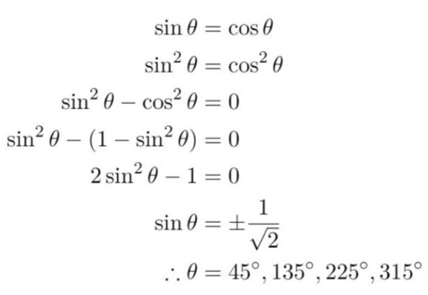
- What is wrong with this solution for solving $\sin{θ}=\cos{θ}$ in $θ∈\left[0°,360°\right]$?

If you square both sides, you introduce new solutions.
If you use this method, substitute the solutions back into the equation to check them.
The only solutions should be $45°,225°$
Another way to solve this is to divide both sides by $\cos{θ}$ to get an equation $\tan{θ}=1$
but if you use this method, remember to check solutions of $\cos{θ}=0$

- Solve $\sin{x}-\cos{x}=0$ for $-π≤x≤π$.

$$x=\frac{π}{4}, -\frac{3π}{4}$$

- Find all solutions of $2\cos{θ}=\sqrt{3}\cot{θ}$ for $0≤θ≤2π$.

$$θ=\frac{π}{3},\frac{2π}{3}$$

- Solve $5\cot^{2}{x}-2\operatorname{cosec}{x}+2=0$ for $0<x<2π$.

$$x=\frac{π}{2}$$

- Solve $2\cos{2θ}=2\sin{2θ}$ for $0≤x≤2π$.

$$θ=\frac{π}{8},\frac{5π}{8},\frac{9π}{8},\frac{13π}{8}$$

Mastery
- 2004 HSC Advanced Band 5
  - Show that $\cos{θ}\tan{θ}=\sin{θ}$.
$$LHS=\cos{θ}\tan{θ}$$
$$=\cos{θ}\left(\frac{\sin{θ}}{\cos{θ}}\right)$$
$$=\sin{θ}$$
$$=RHS$$
  - Hence solve $8\sin{θ}\cos{θ}\tan{θ}=\operatorname{cosec}{θ}$ for $0≤x≤2π$.
$$8\sin{θ}\cos{θ}\tan{θ}=\operatorname{cosec}{θ}$$
$$8\sin{θ}\sin{θ}=\operatorname{cosec}{θ}$$
$$8\sin^{2}{θ}=\frac{1}{\sin{θ}}$$
$$\sin^{3}{θ}=\frac{1}{8}$$
$$\sin{θ}=\frac{1}{2}$$
$$θ=\frac{π}{6},\frac{5π}{6}$$

  - What is the value of $α$ if $\sin{x}=\cos{(α-x})?$
$$α=\frac{π}{2}$$
  - Solve in the domain $x∈\left[0,\frac{π}{2}\right]$:
$$\cos\left(\frac{π}{12}+x\right)=\sin{x}$$
$$\sin\left(\frac{π}{2}-\left(\frac{π}{12}+x\right)\right)=\sin{x}$$
$$\sin\left(\frac{5π}{12}-x\right)=\sin{x}$$
$$\frac{5π}{12}-x=x$$
$$2x=\frac{5π}{12}$$
$$x=\frac{π}{24}$$
No need to consider other quadrants as $x∈\left[0,\frac{π}{2}\right]$

- Solve in the domain $x∈\left[-π,π\right]$
- $\cos^{2}{x}=\sqrt{3}\sin{x}\cos{x}$  $$cos²x = \sqrt{3} sin x cos x$$  $$Divide by cos x (assuming cos x ≠ 0):$$  $$cos x = \sqrt{3} sin x$$  $$tan x =\frac{1}{\sqrt{3}}$$  $$x =\frac{π}{6}, -\frac{5π}{6}$$  $$Check cos x = 0: x = ±\frac{π}{2}$$  $$At x =\frac{π}{2}: 0 = \sqrt{3}(1)(0) ✓$$  $$At x = -\frac{π}{2}: 0 = \sqrt{3}(-1)(0) ✓$$  $$x=-\frac{5π}{6},\frac{π}{2},\frac{π}{6},\frac{π}{2}$$ | - $\cos^{2}{x}-\sin^{2}{x}=3\sin{x}-1$  $$1 - sin²x - sin²x = 3 sin x - 1$$  $$2sin²x + 3 sin x - 2 = 0$$  $$(2 sin x - 1)(sin x + 2) = 0$$  $$sin x =\frac{1}{2} or sin x = -2 (impossible)$$  $$x=\frac{π}{6},\frac{5π}{6}$$
- Solve $\left(\tan{θ}-1\right)\left(\sin^{2}{θ}-3\cos^{2}{θ}\right)=0$ where $0≤θ≤π$.

$$\left(\tan{θ}-1\right)\left(\sin^{2}{θ}-3\cos^{2}{θ}\right)=0$$
$$\left(\tan{θ}-1\right)\left(\sin{θ}-\sqrt{3}\cos{θ}\right)\left(\sin{θ}+\sqrt{3}\cos{θ}\right)=0$$

Consider $\sin{θ}-\sqrt{3}\cos{θ}=0$, divide all terms by $\cos{θ}$:
$$\tan{θ}-\sqrt{3}=0$$
$$\tan{θ}=\sqrt{3}$$
Similarly, $\sin{θ}+\sqrt{3}\cos{θ}→\tan{θ}=-\sqrt{3}$

$$∴\tan{θ}=1 or\tan{θ}=±\sqrt{3}$$
$$∴θ=\frac{π}{4},\frac{π}{3},\frac{2π}{3}$$

  - Prove that $\frac{1}{\sin{x}\cos{x}}$ $-\cot{x}=\tan{x}$
LHS
$$=\frac{1}{\sin{x}\cos{x}}-\frac{\cos{x}}{\sin{x}}$$
$$=\frac{1-\cos^{2}{x}}{\sin{x}\cos{x}}$$
$$=\frac{\sin^{2}{x}}{\sin{x}\cos{x}}$$
$$=\frac{\sin{x}}{\cos{x}}$$
$$=\tan{x}$$
= RHS
  - Hence solve in the domain $x∈\left[0,2π\right]:$
$$\frac{\cos^{2}{x}-1}{\sin{x}\cos{x}}=\sqrt{3}$$
$$\frac{-\left(-\cos^{2}{x}+1\right)}{\sin{x}\cos{x}}=\sqrt{3}$$
$$\frac{-\sin^{2}{x}}{\sin{x}\cos{x}}=\sqrt{3}$$
$$-\tan{x}=\sqrt{3}$$
$$\tan{x}=-\sqrt{3}$$
$$x=\frac{2π}{3},\frac{5π}{3}$$

